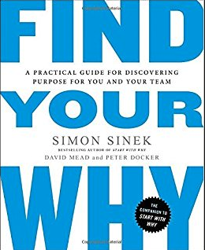
Method 2: The Memory Prompt

- Who in your life has helped make you the person you are today (coach, mentor, teacher, family member)? Write down a specific time when they exemplified what you admire most about them, whether they were interacting with you or with someone else. How did hearing their words or watching their actions make you feel? Who else helped shape who you are today? Repeat as many times as you like.
- Think of a day at work when, as you headed home, you might have said to yourself, “I would have done that for free.” What happened that day to make you say that?
- Think of your worst day at work – the kind of day you hope never to go through again. What happened?
- What is the earliest, specific, happy childhood memory that comes to your mind?
- At school, what was an experience you loved?
- What has been a pivotal moment in your life, one when you realized nothing would ever be the same?
- What happened that changed they way you think about the world and your role in it?
- What was a time when you gave of yourself to help someone else, after which you felt unbelievably good – like you had done something that mattered?
- What have you accomplished that you’re really proud of? (Be sure to make a mental note of who else was involved. For example, who helped you, who cheered you on, who was waiting for you at the finish line?)

